Hills Galore Ride
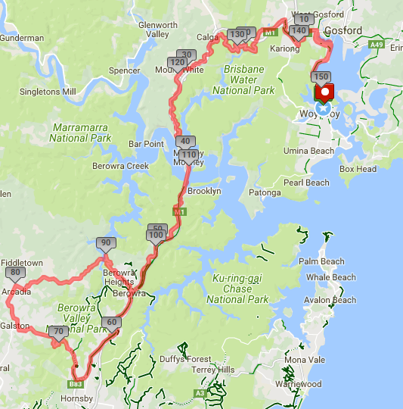
Ride Distance: | 150 kms | Altitude Gain: | 2,700 m
Grade: | Hard | Average Pace¹: | 22-24
Ride Surface: | Road | Est. Duration: | 8+ hrs
Ideal for bike: | Road | Child Suitable^{1&}: | n/a
RidesAssist: | No

Ride Summary:
Mostly riding through national parks, around waterways and through countryside, we take on 7 hill climbs over the 150km distance. Designed for more experienced riders, this is a great training ride for those planning to take on L’Etape, Sydney to Gong Return or any other “challenge” ride.
Several opt-out points are available to reduce the distance and number of hills, with the option of a return train ride.
For more information on this ride including when it is next scheduled, please refer to the CCBUG Rides Calendar at www.ccbug.org.au or checkout our events on Facebook www.facebook.com/CentralCoastBicycleUserGroup

Ride Details

Full Description
May the hills begin! And there are plenty of them on this ride Seven to be climbed (and descended): Kariong, Calga, PitS, Galston, Berowra, Mt White and Somersby. Much of the ride is along the old Pacific Highway so we can relax and enjoy very few other vehicles, although you do need to watch (or listen) out for the motor bikes and the occasional motor car.
Setting out from Woy Woy we ride alongside the beautiful Brisbane Waters to West Gosford, then up Kariong hill (hill #1) to the bus stop for a regroup and signing on any extras. Then we quickly leave the busy Central Coast Hwy and start our ride along old Pacific Hwy through Brisbane Water National Park. Up to Calga (hill #2), then along to Mt White and down to the Hawkesbury River bridge (a fun descent), before a 3km climb (hill #3) up to Pie in the Sky café – likely coffee stop #1.
Continuing our ride along the Old Pacific Hwy heading to Hornsby, we move into more the populated and trafficked areas between Berowra and Asquith. Options to exit the ride at Cowan, Berowra or Asquith/Hornsby for a relaxed train ride home.
At Asquith we turn off and head west via “the gorge”, a fun little set of switch-backs taking us deep into Berowra Valley National Park and up to Galston (hill #4). Before getting into Galston proper, we turn north towards Arcadia, enjoying some country riding past farms of various types. Then it’s down to Berowra Waters where we catch the ferry across Berowra Creek to meet our next climb up to Berowra (hill #5).
Depending on how we feel, our first (or second) coffee stop will soon be had. Either at Berowra, Pie in the Sky or even the Estuary alongside the Hawkesbury River. Rejoining the old Hwy we climb up to Mt White (hill #6), across to Calga, down to Mooney Creek and then up to Somersby (hill #7). With all the climbs over we cruise down Kalga hill to West Gosford and head back to our starting point.
Regroups: Kariong (also an opt-in point); Calga after the climb; PitS for coffee; Asquith to make sure we all turn to Galston; Galston Rd; Berowra at the ferry; Mt White and Kariong.
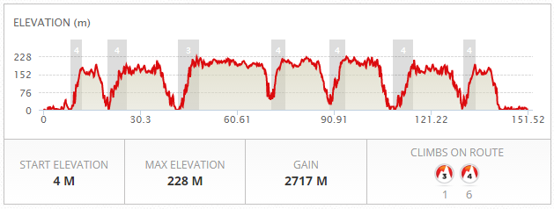

Opt in points
Kariong at the bus stop just after the Shell servo, about 45 mins after ride start time.
Pie in the Sky café Cowan (our first coffee stop), about 2.25-2.5 hrs after ride start time.

Opt out points
Berowra train station after about 55 kms and 3 hills.
Hornsby train station (which is about 3kms from the route) after about 65 kms and 3 hills.
Berowra train station after about 93 kms and 5 hills.
Water & Toilet Locations

Woy Woy train station
Kariong, Shell servo (regroup / opt-in point)
Mount White, Old Highway café (not a normal stop)
Cowan, Pie in the Sky café (normal coffee stop)
Berowra Waters boatshed (not a normal stop)

Map Reference

http://www.mapmyride.com/routes/view/1726559849

Ride Leaders Personal Notes:
Some alternatives:
- Go via Berowra Waters first and come back Galston Gorge (ie, reverse this loop)
- Use shared path from West Gosford back to Woy Woy; may be a good idea after a long ride as people will be tired.

Cue Sheet
Distance Marker (kms) | Direction | Street / Location | Hazards / notes
0 | Left | From Woy Woy train station onto Brisbane Water Drive | Some traffic in shopping area
5 | Right | At the roundabout to stay on Brisbane Water Drive | Point Clare rail overpass; watch for other vehicles entering roundabout
8.5 | Left | Central Coast Highway | Road shoulder narrow in parts up Kariong hill; fast passing traffic
11.5 | Straight | Traffic lights at Woy Woy Rd
12 | Stop | Bus stop just after Curringa Rd.  Opt-in point. | REGROUP  Watch for buses and pedestrians.
12.5 | Straight | Merge into the left traffic lane due to pedestrian island in shoulder at Kangoo Rd lights | Take care merging, OR  Consider crossing at the Kangoo Rd traffic lights onto the shared path if fast moving traffic around.
13 | Right | Wisemans Ferry Rd | Traffic lights; take extra care when changing into the right hand turn lane
13.5 | Left | Pacific Highway
17 | Straight | Pacific Highway | Take care on long descent; may be damp patches on road after rain or tree litter after winds
25 | Stop | Cnr Pacific Highway and Peats Ridge Rd Calga | REGROUP
25 | Left | Pacific Highway
25.5 | Left | Pacific Highway
32 | Straight | Pacific Highway | Take care on long descent; may be tree litter after winds
46 | Stop | Pie in the Sky cafe at the top of the hill.  Regroup point and probably coffee! | REGROUP  Watch for motor cycles
46 | Left | Pacific Highway
54 | Straight | Pacific Highway | Moving into more trafficked area
58 | Straight | Pacific Highway near Beaumont Rd | Shoulder narrows – single file, take care
63 | Stop | Pacific Highway just after Yirra Rd traffic lights near bus stop | REGROUP to ensure all riders together and take next right;  Galston gorge switch-backs coming up!
64 | Move right | Pacific Highway, move into right hand turn lane | If too much traffic, take ramp to left up towards station, then continue straight back down to stop sign at Highway. Then cross when safe into right turn lane.
65 | Right | Galston Rd at traffic lights
71 | Straight | Galston Rd | Bridge over Berowra Creek
74 | Veer right | Galston Rd | Roundabout, watch for traffic
74.5 | Left | Galston Rd
75 | STOP | Galston Rd, just after left turn | REGROUP
75.5 | Right | Arcadia Rd | Roundabout, watch for traffic
78 | Left | Arcadia Rd
78.2 | Right | Arcadia Rd
80 | Right | Arcadia Rd
81 | Left | Arcadia Rd
83 | Right | Bay Rd
86 | Straight | Bay Rd | Start descent, take care!
89.2 | STOP | Bay Rd @ Ferry | REGROUP & catch ferry
89.4 | Straight | Berowra Waters Rd | Start climb; keep left & watch for traffic
93.5 | Left | Berowra Waters Rd
93.6 | Right | Berowra Waters Rd
95.5 | Left | Pacific Highway | Traffic lights
104 | Straight | Pie in the Sky | Possible coffee stop or continue down the hill (whilst warm)
108 | Straight | The Estuary café | Possible coffee stop
120 | STOP | Pacific Highway cnr Morgans Rd traffic lights | REGROUP
126 | Right | Pacific Highway | Calga
126.5 | Right | Pacific Highway
127 | Straight | Pacific Highway | Take care on long descent; may be damp patches on road after rain or tree litter after winds
139 | STOP | Central Coast Highway just before cnr The Avenue | REGROUP
139 | Straight | Central Coast Highway | Descend Kariong hill as one group two abreast taking the left traffic lane; watch for damp areas on sweeping bends
142 | Move Right | Central Coast Highway | Take right hand lane then right hand turn lane
142.5 | Right | Brisbane Water Drive
143 | Merge right | Brisbane Water Drive | Merge right over single lane bridge
145 | Straight | Brisbane Water Drive | Narrow shoulder; single file
146 | Straight | Brisbane Water Drive | Narrow shoulder; single file
146.5 | Left | Brisbane Water Drive | Roundabout
150 | Straight | Brisbane Water Drive | Narrow shoulder over bridge; single file
151 | STOP | Brisbane Water Drive Woy Woy | The end

Refer to the Rides Grading page at www.ccbug.org.au for more information.
Refer to the Ride Requirements page at www.ccbug.org.au for more information.

