Terrigal to Norah Head (Return)
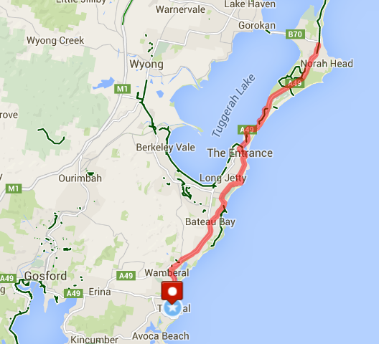

Ride Distance: | 53kms | Altitude Gain: | 390m
Grade: | Medium Hard | Average Pace¹: | 24-26 km
Ride Surface: | Road | Est. Duration: | 2.5 – 3 hrs
Ideal for: | Road Bikes | Child Suitable¹: | n/a

Ride Summary:
A Medium to Hard grade ride leaving from the popular ritzy beachside area of Terrigal, passing through The Entrance and heading up to Norah Head before returning. The ride starts and ends at the Terrigal Surf Club carpark. This ride is perfect for those stepping up from moderate rides like the CCBUG Social Tuggerah Lake ride and the Brisbane Waters Loop ride.

All on road shoulders, with some normal traffic roads, so you need to be comfortable cycling on the road with some passing traffic. Ride pace will be slower going over The Entrance bridge as it can be quite windy.

Coffee will be at the Terrigal Surf Café upon completion (also an optional coffee stop at Norah Head if time permits).
For more information on this ride including when it is next scheduled, please refer to the CCBUG Rides Calendar at www.ccbug.org.au or checkout our events on Facebook www.facebook.com/CentralCoastBicycleUserGroup
Ride Details –
You need to be comfortable cycling on the road/road shoulder with some fast passing traffic. The pace will be fast (24 – 26km/h) however in sections the ride pace will reduce for conditions such as The Entrance bridge that can be windy.

This ride is suitable for road bikes and flat-bar road bikes or hybrid/urban bikes.
As it is generally run at a fast pace, a strong cycling fit rider might choose a mountain bike.

This ride is fairly flat, although there are a couple of short hills along Wilfred Barrett Drive from The Entrance to Norah Head.
A total of 390 metres climbed.

There are a couple of sections of the ride which require cyclists to as a group, take over a road lane to more safely turn right, therefore you need to be comfortable to stay with the pack and to look over your right shoulder to make sure the road is clear behind you before moving out on to the road for the turn.

Opt in points

The ride will start at Terrigal Surf Club carpark. There are no other opt in points for this ride.

Opt out points

There are no train stations on the route, however there are bus stops along the way which would take you to Gosford or The Entrance (if the bus driver lets you on with your bike).
You can turn around at any point and retrace the route, but please let the ride leader or sweep know BEFORE you leave the ride!

Water & Toilet Locations

Water can be filled at The Surf Café prior to starting the ride and at the Norah Head turn around point.

Toilets are located at Terrigal Surf Club, The Entrance, and at the Norah Head turn-around point. If you need to go, please let the ride leader know (discretely).

Map Reference:

http://www.mapmyride.com/routes/view/1086023482

Ride Leaders Personal Notes:

Cue Sheet –

Distance Marker | Direction | Street / Location | Hazards / notes
0.0 | Start | Commence at Terrigal SLSC Carpark | Terrigal Drive, cnr Painters Lane
0.0 | Right | Leave the car park, turning right onto Terrigal Drive | Watch for traffic in both directions
0.0 | Straight | Proceed over the hill and down to the roundabout onto Ocean View Drive | Watch for passing traffic
0.6 | Right | At the roundabout turn right onto Ocean View Drive | Watch for traffic, busy intersection
0.6 | Straight | Proceed along Ocean View Drive until Wairakei Road | Watch for traffic before moving into the lane to turn right
2.8 | Right | Turn right into Wairakei Road and proceed 0.5km to Matawai Ave | Right turn is at the base of a hill, busy road
3.2 | Right | Turn right into Matawai Ave and follow to end and stop at the stop sign | Stop sign
3.3 | Left | Turn left onto Blue bell drive, proceed to end of road and veers to the right and continue to the roundabout
3.6 | Left | At the roundabout turn left onto pitt road and proceed up to the traffic lights
3.7 | Right | At traffic lights turn right onto The Entrance Road (C C highway) and proceed for 4.5km along the highway | Proceed straight along the Highway, taking care at the roundabouts.
8.2 | Right | Turn right at traffic lights into Bateau Bay Road | traffic lights, busy road - caution needed to get to the right hand turning lane – you will need to cross 2 lanes of traffic
 | Straight | Proceed along Bateau Bay road for approximately 2.5km to the roundabout
10.6 | Right | Turn right at round about onto Grandview Street | proceed nth bnd, up the slight incline and straight through next round-about – still on Grandview Street
10.6 | Straight | Proceed up the slight incline and straight through the next roundabout and follow to Swadling Street
12.1 | Right | Turn right at roundabout Swadling Street
12.5 | Right | Turn Right at roundabout into koongarra Street | Road veers to the left & turns into Bay Road
12.5 | Straight | Proceed along Koongarra Street, road veers to the right and changes into Bay Road
14.0 | Right | Turn right at roundabout into Boondilla Road and proceed to end of road
14.1 | Left | Turn left into Ocean Parade and proceed along to Fairport Ave
14.8 | Right | Turn Right onto Fairport Ave and proceed through the roundabout and continue to the end of the street
15.1 | Left | Left onto Marine Pde and proceed along 0.5km along the waterfront, past the carpark and through the set of traffic lights at bottom end of town where the corso starts | This street changes to Coral Street at the traffic lights
15.6 | Straight | Proceed on Coral Street to roundabout
15.8 | Right | Turn right at roundabout onto Wilfred Barret Drive | Proceed to end of wilfred barrett drive - once get to the cemetery,
15.9 | Straight | Proceed over The Entrance Bridge | Bridge can be very windy and heavy traffic at times. Proceed with caution
16.0 | Straight | Proceed along Wilfred Barrett Drive for approximately 10.5km to Norah Head
26.5 |  | Regroup and wait for riders to return in the same direction as we came
26.5 |  | Cross over Wilfred Barrett Drive and head back toward the Entrance
26.5 | Straight | Proceed along Wilfred Barrett Drive for approximately 10.5km to The Entrance
37.0 | Straight | Proceed over The Entrance Bridge | Bridge can be very windy and heavy traffic at times. Proceed with caution
37.5 | Left | Turn left at roundabout into Coral Street and proceed through traffic lights
38.0 | Left | Turn left into Marine Parade and follow along the waterway
 | Straight | Proceed along Marine Parade until the very end
39.0 | Right | Turn right into Dening Street
39.1 | Left | Turn left into Ocean Parade and proceed along to the end
39.8 | Left | Turn left into Bay Road
39.8 | Straight | Proceed along Bay Road until the end and it veers to the right and changes to Koongara
41.5 | Right | Turn right into Koongara Street
42.0 | Left | Turn left at roundabout into Swadling
42.0 | Straight | Proceed along Swadling until the next roundabout
43.6 | Left | Turn left at roundabout into Grandview St
43.6 | Straight | Proceed along Grandview, through the next roundabout and at the second roundabout turn left into Bateau Bay Road
44.6 | Left | Turn left on to Central Coast Highway
44.6 | Straight | Proceed along Central Coast Highway for 5km and turn left into Pitt Road at the traffic lights
49.6 | Left | Turn left at traffic lights into Pitt Road
49.7 | Right | Turn right at Roundabout into Blue Bell Drive
50.0 | Right | Turn right into Matawai Avenue
50.1 | Left | Turn left into Wairakei Road
50.5 | Left | Turn left into Ocean View Drive
50.5 | Straight | Proceed along Ocean View Drive to roundabout
52.7 | Left | Turn left at roundabout onto Terrigal Drive
52.7 | Straight | Proceed along Terrigal Drive to Terrigal Surf Carpark.
53.3 |  | Enter carpark

Refer to the www.ccbug.org.au for more information.

