CCBUG Gosford To Newcastle

(via fernleigh track)
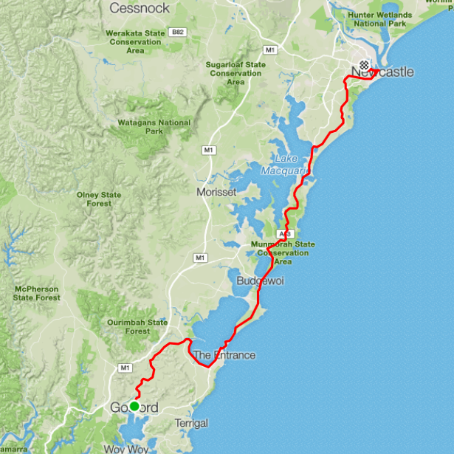
Ride Distance: | 103kms | Altitude Gain: | 666 m
Grade: | Medium-Hard | Average Pace1: | 21-23 kph
Ride Surface: | Road & Shared Path | Est. Duration: | 5hrs + Return
Ideal for: | Experienced Riders | Child Suitable1&: | n/a
RidesAssist: | No

Ride Summary:
A ride for those that love and crave distance, this route takes you from Gosford train station, heading north through the Central Coast up to Swansea, then into Belmont where the ride takes the Fernleigh track all the way to Adamstown. From there the ride heads into Newcastle Waterfront for lunch, before coming back to Hamilton train station, where the group catches a train home.
For more information on this ride including when it is next scheduled, please refer to the CCBUG Rides Calendar at www.ccbug.org.au or checkout our events on Facebook www.facebook.com/CentralCoastBicycleUserGroup
Ride Details:
A ride from Gosford to Newcastle via the Fernleigh Track, returning by train.
This ride will be starting at Gosford train station, with the meeting point being on the Hospital side of the station. The ride is going to be predominantly on the road.
We head north down Showground Road all the way to Manns Rd, then out through Narara Valley joining the Pacific Hwy at Lisarow. Then turning right onto Chittaway Rd and continuing along Enterprise Drv for a speed blat (if required).
At Wyong Rd we continue straight on (after stopping at the traffic lights if required) to Chittaway Road, with a short regroup at Chittaway public school – our second pick up point.
We will then continue north to the end where we will turn right on to Lakedge Avenue. Lakeedge avenue will take us to the Shared bike path. The shared path runs up to and alongside Tuggerah Lake all the way to The Entrance. There are public facilities along this path. There will be an option for us to have a coffee or breakfast at the Entrance.

Next we cross the Entrance bridge through to Wilfred Barret which has a good road shoulder and long straight section where those who can, may stretch their legs and push on to the regroup beside the Noraville Cemetery.

After the regroup we continue along the Central Coast Hwy and on to Elizabeth Bay Drive, following it until we turn at the lights onto Birdie Beach Drive. This will take us through the Munmorah State Conservation Area

Along the Pacific Hwy we use the road shoulder which generally has plenty of room except for a couple of short squeeze points. This is where the vehicular traffic will be quite fast, so keeping in the shoulder and to the left is important. A few short hills until we reach the nice downhill into Swansea.

Watch out for the road shoulder disappearing before the big roundabout at the bottom of the hill. Two options here are to take the shared path on the left or take the lane and mix it with the traffic at the roundabout.

As we approach Swansea we will be calling in to the McDonalds for a well-deserved rest where we can have a coffee and light refreshments. After we recharge we will need to take care of parked cars, and take the lane over the Swansea bridge. Return to the shoulder after the bridge which takes us all the way into Belmont.

Taking the left turn towards the Lake Macquarie Yacht Club before reaching Belmont township, then first right into Walter St and first right into Victoria St to cross the Pacific Hwy at traffic lights and straight into Railway Parade.

Now we get to enjoy one of the few New South Wales rail trails, the Fernleigh track, all the way into Adamstown. We wander through local bushland, pass by some old railway stations, and finally through a beautifully architected train tunnel before reaching the end of the trail. Then it’s back on the road in to Newcastle. We will then stop for lunch and a drink and a break at a venue of choice.

Facebook Posting:

A ride for those that love and crave distance, this ride is approximately 103 km in distance and is paced at approximately 22kph.
The route takes you from Gosford train station, (meeting on the hospital side of the station), we head north along the Pacific Highway to Ourimbah, the ride turns right and continues along Enterprise Drive, through to Chittaway Bay Public School, which is the second pick up point.
From here the ride continues along the shared path alongside Lakedge Avenue all the way to The Entrance, stopping at The Entrance for breaky.
Proceeding from here we ride north bound up to Budgewoi, where we turn right at the round about and continue along Elizabeth Bay drive, detouring through the National Park and turning right onto the Pacific Highway, taking this all the way to Swansea, there are some climbs on this stretch and you need to be comfortable with passing traffic.
After a brief stop at Macdonalds Swansea, the ride continues to Belmont, where we head onto the gorgeous Fernleigh Track, taking that all the way to Adamstown.
We then head into Newcastle Waterfront to enjoy lunch with a view, before riding back to Hamilton train station, giving our legs a well deserved rest on the train ride back to the Coast.

Opt in points

There will only be one Opt in point and this will be at Chittaway Public School

Opt out points

The last logical Opt Out point would be Elizabeth Drive & Pacific Highway, Lake Munmorah.

Please advise the Ride leader if you intend leaving the ride early.

Water & Toilet Loctions

There are toilets along the shared pathway around Tuggerah Lake. At the Entrance under the bridge, At McDonalds at Swansea and at the final destination.

Parking
There is ample room in the Multi story car park at Gosford station or you may park on the side of the road along Showground road close to the station. Or catch a train to the start!

Map Reference: https://www.strava.com/routes/5042684

Ride Leaders Personal Notes:

Cue Sheet -
Distance Marker | Street / Location | Hazards / notes
0 | Start at Gosford Train Station, West side
0 | Head North on Showground Road
0.5 | Right at roundabout onto Racecourse Road
0.6 | Left onto Mann Street (at traffic light)
2.4 | Left onto Pacific Highway at 5 ways roundabout Wyoming
 | Continue North through Narara, Niagara Park and Lisarow | Narrow road shoulder in parts
13.5 | Right at Ourimbah roundabout onto Brownlee Street | Take right lane before roundabout
13.6 | Continue onto Enterprise Drive | Narrow road shoulder in parts
 | Continue straight through large roundabout at Wyong RD
 | Pickup point at Chittaway Bay Public School | Opt in point
21.8 | Head North on Chittaway Road
21.9 | Turn right on to Lakedge Avenue | Beware of pedestrians & dogs on the shared path along lakedge ave
32.7 | Left onto The Entrance Road
33.7 | Left onto Oakland Avenue
33.8 | Left onto Bent Street | Use pathway over bridge
34.8 | Proceed onto Wilfred Barrett Drive
 | Continue through Noraville roundabout | Noraville; Take the right lane before the roundabout
48.3 | Turn right at roundabout onto Ourringo Street | Budgewoi
48.7 | Continue on Mimosa Road
49.2 | Continue on Elizabeth Bay Drive
53 | Right
53 | Continue on Birdie Beach Drive
54.5 | Continue on Blue Wren Drive
56.8 | Continue on Kanangra Drive
56.9 | Right onto Pacific Highway
 | Coffee stop at Swansea McDonald's | Coffee stop at Swansea McDonald's (left at roundabout)
77 | Right onto Victoria Street
77 | Proceed onto Railway Parade
79 | Proceed onto Fernleigh Track
97.2 | Left onto Park Avenue
97.5 | Right onto Glebe Road
101.3 | Left onto Kenrick Street
101.4 | Right onto Corlette Street
102.6 | Right onto Laman Street
102.9 | Left onto Auckland Street
103.1 | Right onto Hunter Street | Avoid tree roots
103.3 | Left onto Merewether Street
103.5 | Right onto Wharf Road
 | Lunch stop on Newcastle waterfront
103.6 | Head west on Wharf Road
105.6 | Proceed onto Honeysuckle Drive | Beware of pedestrians with dogs
106.8 | Left onto Stewart Avenue(Pacific Highway)
107.2 | Right onto Parry Street
108 | Continue on Donald Street
108.5 | Right onto Beaumont Street
108.6 | Arrive at Finish (Hamilton Station)

Refer to the Rides Grading page at www.ccbug.org.au for more information.
Refer to the Ride Requirements page at www.ccbug.org.au for more information.

