Peninsula Pedal
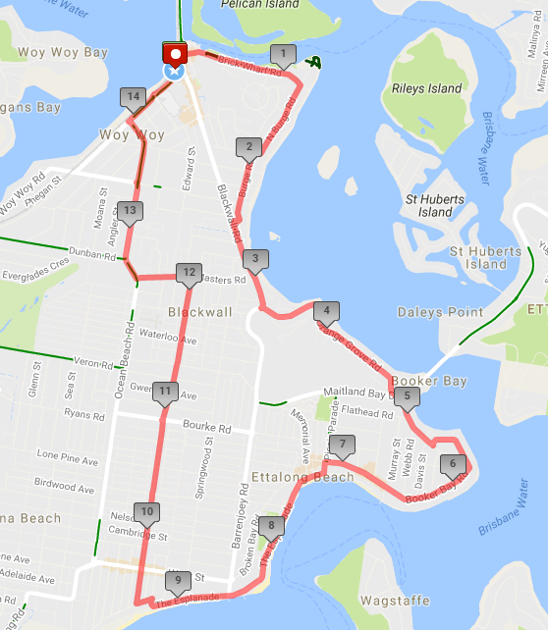
Ride Distance: | 15 kms | Altitude Gain: | 90 m
Grade: | Easy | Average Pace¹: | 15-17kph
Ride Surface: | Road | Est. Duration: | 1.5 hrs
Ideal for bike: | Any | Child Suitable^{1&}: | 13+
RidesAssist: | Yes

Ride Summary:
An easy ride around the streets of the Peninsula, providing an opportunity for less experienced riders to gain some confidence on the road in the relative safety of a small group ride.
Coffee stop either at Ettallong/Umina, or back at Woy Woy upon completion.

For more information on this ride including when it is next scheduled, please refer to the CCBUG Rides Calendar at www.ccbug.org.au or checkout our events on Facebook www.facebook.com/CentralCoastBicycleUserGroup

Ride Details

Full Description
A slow paced ride starting at Woy Woy Station and riding around mostly quiet streets of the Peninsula. We pass by some million dollar properties facing Brisbane Waters, through the upmarket areas or Orange Grove and Booker Bay, then skim the Ettalong and Umina beach areas and get a great view of Lion Island and Barrenjoey lighthouse in the background.
Then it’s back through Umina shopping area, which can be a little busy, and along Trafalgar Ave all the way to McMasters Rd. We then utilise the traffic lights to safely turn right into OB Rd and eventually onto Railway Pde and back to our starting point.
Coffee stop possible at Ettalong or Umina beach, or back at Woy Woy upon completion.

Opt in points
Woy Woy station only.

Opt out points

No easy public transport opt-out points on this ride. There are buses which service the area, but they are unlikely to allow you to carry your bike on the bus
You can opt out anywhere, but please advise the Ride Leader before you leave the ride.
Water & Toilet Loctions

Woy Woy station has toilets and water
Ettalong beach has toilets and water
Umina beach has toilets and water

Map Reference

http://www.mapmyride.com/routes/view/1475781511

Ride Leaders Personal Notes:
You could lead this ride in reverse (turning mostly left), heading down OB Rd then Trafalgar and back via Booker Bay. However, getting out of Orange Grove and back onto Blackwall Rd turning right would be a challenge. There is a shared path on the eastern side of Blackwall Rd as a possible alternative to this turn.
If no tandems, you could also turn right off McMasters Rd into Fairview St then through the park and onto Edward St. Note that from the end of Fairview St the route can be quite rough, with some gravel and possibly muddy if recent rain, until you get onto Edward St. Then it’s left onto Victoria Rd, right onto Charlton St at the roundabout and right onto Railway St at the roundabout. It can be quite busy in this area.

Cue Sheet
Distance Marker | Direction | Street / Location | Hazards / notes
0 | left | Brisbane Waters Drive | Leave the station bus area
0.1 | right | The Boulevarde | Immediately get into the right hand turn lane; watch for oncoming and turning traffic
0.2 | straight | Brick Wharf Rd | Watch for traffic from Oval Ave (right) and The Boulevarde (left)
1.1 | Right | North Burge Rd | Watch for traffic from North Burge Rd (left)
1.7 | Right | Park Rd | Road narrows just before the turn
1.8 | Left | Burge Rd
2.2 | Left | Blackwall Rd | Enter at the traffic lights opposite PLC
2.9 | Left | Blackwall Rd | Small hill ahead!
3.4 | straight | Orange Grove Rd
4.3 | Veer right | Booker Bay Rd
5.0 | Veer left | Booker Bay Rd
6.8 | Left | Picnic Parade / The Esplanade | Watch for traffic at roundabout!
7.0 | Straight | The Box coffee shop | If required, stop for coffee / toilet / water
9.5 | Right | Norman St | Watch for vehicles reversing from front to curb parking beside beach
9.6 | Left | The Esplanade
9.7 | Right | Trafalgar Ave
10.0 | Straight | Trafalgar Ave | Across the roundabout – watch for traffic!
12.2 | Left | McMasters Rd
12.5 | Right | Ocean Beach Rd | At the traffic lights – use left hand lane  Watch for cars turning left into Dunban Rd!
13.5 | Right | Railway St | At the traffic lights – use right hand lane.  Do NOT use the “door zone” lane along Railway St – take the lane!
14.1 | Left | Railway Bus road
14.2 | Stop | End of the ride

Refer to the Rides Grading page at www.ccbug.org.au for more information.
Refer to the Ride Requirements page at www.ccbug.org.au for more information.

