CCBUG Woy Woy To Newcastle (via Fernleigh track)
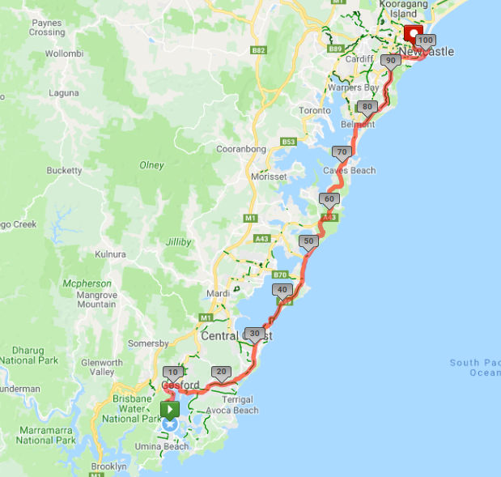
Ride Distance: | 104kms | Altitude Gain: | 850 m
Grade: | Hard | Average Pace1: | 22-24 kph
Ride Surface: | Road & Shared Path | Est. Duration: | 6hrs + Return
Ideal for: | Road bikes | Child Suitable1&: | n/a
RidesAssist: | Experienced only – booking required

Ride Summary:
A ride for those that love longer distance rides without too many hills. This one from Woy Woy station to Newcastle via Central Coast Hwy, Pacific Hwy and Fernleigh Track. With a coffee stop at Swansea, optional lunch at Newcastle foreshore and a return train ride, this is a “most of the day” type ride.
Option to cycle back as well if you’re feeling up to it – but that bit is without support and not recommended if you have partaken of an alcoholic beverage at lunch!
For more information on this ride including when it is next scheduled, please refer to the CCBUG Rides Calendar at www.ccbug.org.au or checkout our events on Facebook www.facebook.com/CentralCoastBicycleUserGroup
Ride Details:
A ride from Woy Woy to Newcastle via Brisbane Water Drv, Central Coast Hwy, Pacific Hwy and the Fernleigh Track, returning by train.
This ride will start at Woy Woy train station, predominantly being on the road / road shoulder with some fast passing cars in some sections so you need to be confident in this type of environment.
Most of the on road sections have good road shoulders for us, but we still need to be aware of vegetation and vehicle debris, drain grates, and of course rogue motor vehicle drivers and other cyclists.
After joining the Pacific Hwy we enjoy a few short hills until we reach the nice downhill into Swansea where we stop for coffee. Next we head to Belmont where we join the Fernleigh Track – an old disused railway line running all the way to Adamstown. The slight uphill gradient for most of the tracks 16kms makes it a little challenging. But the jewel in the crown is the beautifully architected brick railway tunnel near the end.
We then jump back on to the road, through the suburbs and towards Bar Beach for a nice view of the water before we climb up and over Shepherds Hill and roll down into Newcastle harbour foreshore for lunch.
After lunch we ride a short distance to the Newcastle Interchange for a train ride home.
Getting to the start:
- Ride from home to the start, or one of the optional Opt In points.
- Catch a train to Woy Woy station with your bike.
- Car parking available in the Multi story car park.

Opt in points

There will only be one formal Opt in point and this will be at the Entrance just north of the bridge at Terilbah Reserve opposite Roberts St (before we get onto Wilfred Barret Drv).

Opt out points

After we leave the Gosford area there is no real train option until we get to Newcastle.

The last logical Opt Out point would be Elizabeth Drive & Pacific Highway, Lake Munmorah where you can turn around and retrace your wheel marks.

Please advise the Ride leader if you intend leaving the ride early.

Water & Toilet Locations

There are toilets & water available at:
- Woy Woy station
- Along the shared path at Long Jetty & the Entrance
- The café at Swansea (probably McDonalds)
- Our lunch stop at Newcastle

Map Reference: https://www.mapmyride.com/routes/view/2622484774

Ride Leaders Personal Notes:
Option to:
- Continue along The Entrance Rd (CC Hwy) from Long Jetty into The Entrance, but look out for the repeating disappearance of the left lane and/or parked cars! And don’t forget to drop by the pickup point at the Lake House.
- bypass Munmorah State Conservation Area, which has a nice little short hill to test the legs, and continue on Elizabeth Bay Drv to join Pacific Hwy.
- add in a loop via Catherine Hill Bay
- take Victoria St at Adamstown as far as Brunker Rd instead of Glebe Rd to avoid the (sometimes tricky) right turn from Park Ave into Glebe Rd. Although I heard they are suppose to be fixing this intersection.
- Turn left off Glebe Rd into City Rd at The Junction, and follow City Rd all the way to Honeysuckle Drv (turn right), then into the harbour foreshore area via the foreshore shared path, avoiding Shepherds Hill.

Cue Sheet -
Distance Marker | Street / Location | Hazards / notes
0 | Start at Woy Woy train station | Near Bus Stop A
0 | Left onto Brisbane Water Drv | At traffic lights out of station area
8.8 | Right onto Central Coast Hwy | At traffic lights – use left right hand turn lane
30 | Continue along CC Hwy / The Entrance Rd | Busy roundabout!
30.4 | Left onto Tuggerah Pde
30.5 | Right onto Tuggerah Pde
32 | STOP if required for toilet | At the Long Jetty long jetty toilets
32.5 | Veer left onto shared path | Watch for pedestrians and other cyclists
33.5 | Straight onto Tuggerah Pde road | Watch for cars on your right
34.2 | Right onto The Entrance Rd
34.7 | Right onto Oakland Avenue
34.8 | Left onto Bent Street | Use pathway over bridge; watch for sand/gravel exiting Bent St
34.9 | Left onto Central Coast Hwy and over bridge | Use pathway over bridge; watch for sand/gravel exiting Bent St
35.5 | STOP at Denniss Park on left just after bridge | Pickup location
35.6 | Continue along Central Coast Hwy & on Wilfred Barrett Drive | Watch out for Wilfred the magpie!  Watch for debris along shoulder and fast passing cars.
45 | Continue through Noraville roundabout | Noraville; Take the right lane before the roundabout
48.8 | Turn right at roundabout onto Ourringo Street | Budgewoi
49.3 | Continue on Mimosa Road
50 | Continue on Elizabeth Bay Drive
53.4 | Continue on Elizabeth Bay Drv | Straight at roundabout
53.6 | Right onto Birdie Beach Drive | At roundabout; short steep hill soon!
55 | Left onto Campbell Drv
55.8 | Continue straight on Blue Wren Drv
57.5 | Right onto Pacific Highway | At the traffic lights; use shoulder  Watch for debris in shoulder & fast passing traffic
71 | STOP at Swansea for coffee | Coffee stop at Swansea McDonald's (left at roundabout)
71 | Rejoin Pacific Hwy heading north | Take the left lane just before the bridge; take care on the bridge due to the metal grid road surface!
77.5 | Left into Ada St Belmont
77.6 | Right into Waker St
77.7 | Right into Victoria St
77.8 | Straight onto Gen St | Straight across Pacific Hwy at traffic lights
78.2 | Right onto Fernleigh Track | Watch for narrowing ballet bars along the track as well as pedestrians and other cyclists; several road crossings as well.
93.4 | Left onto Park Avenue
93.6 | Right onto Glebe Road | Watch for cars on right and left!
97.8 | Veer left onto Darby St
97.9 | Right onto Parkway Ave | At roundabout
98.2 | Left onto Memorial Drv
98.5 | Climb up Shepherds Hill | Note the Memorial Walk overlooking the cliff
99.2 | Left into High St
99.5 | Right into Bingle St which becomes Reserve Rd
100 | Left into Watt St
101 | Left into Wharf Rd
101.5 | STOP at harbour foreshore café | Use shared path along foreshore
101.5 | Rejoin Wharf Rd heading west
102 | Right onto Honeysuckle Drive | At roundabout
103.5 | Right onto City Rd then immediately left to Newcastle Interchange station
103.7 | STOP and catch the train home!

Refer to the Rides Grading page at www.ccbug.org.au for more information.
Refer to the Ride Requirements page at www.ccbug.org.au for more information.

