CCBUG Tuggerah Lake Loop
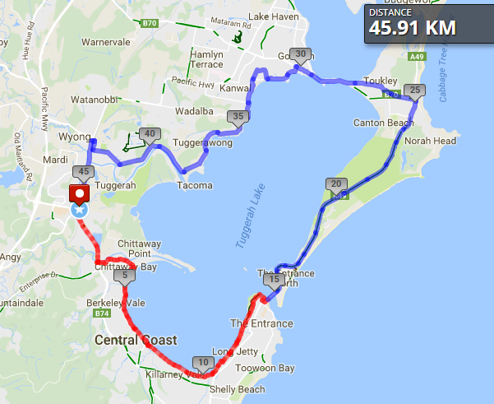
Ride Distance: | 46 kms | Altitude Gain: | 200 m
Grade: | Medium | Average Pace¹: | 21-23 kph
Ride Surface: | Road & Path | Est. Duration: | 2.5 hrs
Ideal for: | Road bike | Child Suitable¹: | 13+ experienced
RidesAssist: | Yes

Ride Summary:
A nice cruising paced ride around Tuggerah Lake, sometimes lapping at the shores of the lake and sometimes weaving through the suburbs. Starting at Tuggerah train station and utilising some shared paths but mostly on the road/road shoulder. Riding slower on the shared path section, but pumping the pedals along Wilfred Barrett Drive shoulder. But watch out for Wilfred, the sometimes overly friendly Magpie!
Note: some sections of the ride noted as on shared path may be substituted by road.
Ride Details –
A nice cruising paced ride around Tuggerah Lake, sometimes lapping at the shores of the lake and sometimes weaving through the suburbs.
We start at Tuggerah train station and immediately jump on the shared path heading under Wyong Rd and then heading east along the Wyong Rd shared path to Chittaway. Jumping onto the road for a short while we soon return to shared path following along the lake shore.
Perhaps a quick stop at the “long jetty” at Long Jetty to read about it’s history, or just to visit the local toilet (an out of body experience?), before continuing north and leaving the shared path at Picnic Point Reserve.
Around the point and right past the Lakehouse, we take a left off Oakland Ave into dead-end Bent Street where a short regroup may pickup some extra riders before joining Wilfred Barrett Drv via a short cross-country section (either shared path or road shoulder over the Entrance bridge), before we start winding up to “warp speed” (whatever that is for you) after Magenta Shores. Enjoy the speed before we slow to a cruising pace through the higher traffic areas of Noraville and through Toukley and over the bridge to Gorokan.
Another lefty off Wallarah Rd as we wind our way along the north west side of Tuggerah Lake via Tuggerawong, then up alongside Wyong Creek to Wyong station.
Nearly back to the beginning we jump on to the old Pacific Highway and then the bicycle path along Tuggerah straight. The End.

Opt in points
The Entrance, cnr Bent St and Wilfred Barret Drv.

Opt out points
The Entrance, cnr Bent St and Wilfred Barret Drv.
Wyong train station
Water & Toilet Loctions
Long jetty jetty
Picnic Point Reserve The Entrance

Map Reference:

http://www.mapmyride.com/routes/view/1890354443

Ride Leaders Personal Notes:
Include any alternate routes/detours, or other points of interest

Cue Sheet –

Distance From Start | Direction to turn | Street / Location | Hazards / notes
0 | Left | Shared path along Pacific Hwy
0.2 | Straight | Shared path under Wyong Rd | Watch for steep descent and bollards?
0.3 | Left | Shared path under Wyong Rd
2.4 | Right | Shared path
2.5 | Right | Shared path under Wyong Rd
2.7 | Left | Chittaway Rd | Watch for cars
4.0 | Right | Lakeridge Ave | Watch for cars
4.2 | Left | Shared path | Watch for bollards
11.6 | Stop | Long jetty jetty | Bikes off the path while you read about the long jetty; toilet stop
14 | Right | The Entrance Rd
15.2 | Right | Oakland Ave
15.3 | Left | Bent St
15.4 | Stop | Bent St | Pickup others; short cross-country section
15.4 | Left | Wilfred Barrett Drv | Over bridge over use shared path or shoulder
16.5 | Straight | Watch out for Wilfred the magpie
24.2 | Regroup | Wilfred Barrett Drv | Optional regroup point
25.1 | Left | Main Rd
29 | Straight | Main Rd then Wallarah Rd | Narrow bridge
30.1 | Left | Lakeview Ave
30.2 | Right | Lett St
30.6 | Left | Leichardt Rd
30.8 | Left | Brennon Rd
30.8 | Right | Marks Rd
32 | Left | Donald Ave
33 | Straight | Tuggerawong Rd
37.5 | Straight | Wolseley Ave
39.8 | Straight | McDonagh Rd
41.3 | Veer Right | Boyce Ave
42 | Straight | Warner Ave
42.8 | Right | Howarth St
43 | Left | Roundabout then over the trainline
43.1 | Left | Pacific Hwy
44 | Straight | Pacific Hwy | Shoulder disappears, merge into lane
44.2 | Veer Left | Bicycle lane along Pacific Hwy
46 | Stop | Tuggerah train station | The end!

For more details on Grading, Avg Pace and Children on rides, checkout www.ccbug.org.au
Estimated duration includes normally planned stops such as for regroups and coffee, but excludes mechanicals.

