AWABA MTB XC RED LOOP
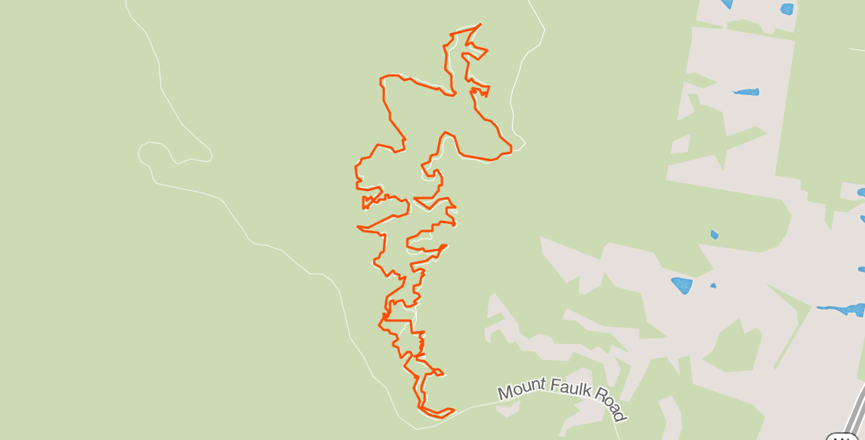
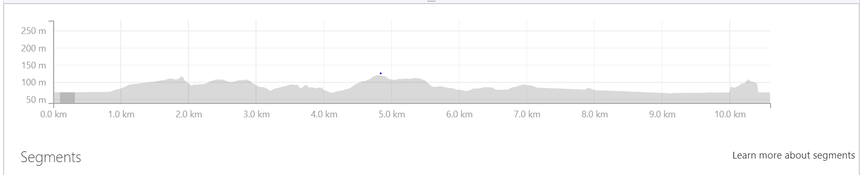
Ride Distance: | 10.5 | Altitude Gain: | 215m
Grade: | Medium | Average Pace: | 11 km/h
Ride Surface: | Single Trail | Est. Duration: | - – 1.5 hrs  (with stops)
Ideal for: | MTB only | Child Suitable: | 12 years +  Or experienced
RidesAssist: | No

Ride Summary:
An easy-to-medium grade MTB ride on mainly single track with minor sections of fire trail. The trail is well signposted, one-way so we won’t lose anyone. We will go as fast as the slowest rider and stops will be made on the difficult bits to help any newbies.
A favourite track because it is well balanced between obstacles and riding with tight twisty sections, fast flowing fun sections, some challenging climbing and some nice gravity built in.

For more information on this ride including when it is next scheduled, please refer to the CCBUG Rides Calendar at www.ccbug.org.au or check out our events on Facebook www.facebook.com/CentralCoastBicycleUserGroup

Ride Details:
Meeting Point: Car park: Jenkins Road – as below
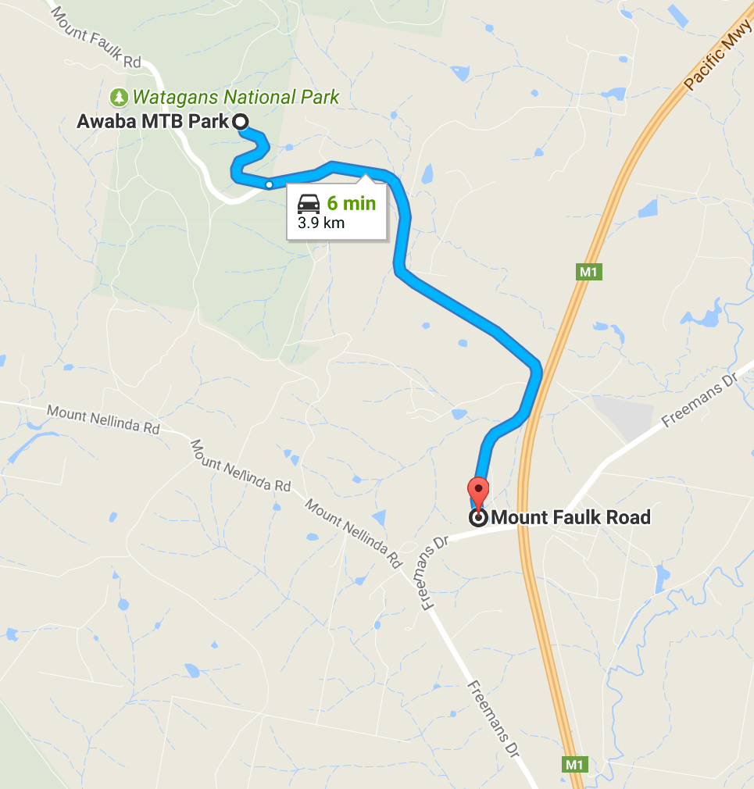
Enter via Mount Faulk Rd off Freemans Road, via Cooranbong (about 10 minutes or 9km North).
Be careful as the signposting is not good and the left turn on to Mount Faulk Road may be easily missed.
Approximately 4kms on Mount Faulk Road turn right onto Jenkins Road, which looks like a fire trail. You will see a sign denoting the area as part of the Hunter Mountain Bike club. Follow Jenkins Road to the main car park, it’s a dirt road but should be easily navigated by family car.

Please NOTE: Toilet facilities consist of a long drop – so your comfort is up to you…

From the car park, the ride is 99% single track. The direction and flow of the track is well sign marked with opt-out to the carpark trails along the way.

- We have one serious climb called Camelback hill. It’s a grade 4 and about 250 metres long, but it steepens and is just a bit cruel. We go straight up, however there is a series of switchbacks which make the climb easier.
- Only two kind of serious hazards – one rock garden the other a very steep descent. I’ll stop ahead of these for the uninitiated/beginners.

Mountain biking is quite testing on fitness levels as the pedalling differs significantly from road. The effort is intense and is often delivered in bursts to get over the obstacles.

Fast riders are welcome to join in, head off early and fast and lap us on the way through (John Hallett?)

This is my favourite track because it is well balanced between obstacles and riding with tight twisty sections, fast flowing fun sections, some challenging climbing and some nice gravity built in. We promise everyone will be talking about the “Salad Bowl” section.

On the super-challenging sections, I will stop in advance to forewarn anyone unfamiliar with the track or uncertain of their abilities. I will also be stopping at all intersections/forks on the trail to keep us as a group. So, to those familiar with the track there will be several stops.

You will need:
- a fully functioning mountain bike, in good service and ready to go.
- Full compliment of at least the basic safety gear including;
  - Helmet
  - Gloves
  - Eyewear (really important – lots of branches at eye level on the single track)
  - Shoes
  - Elbow/Knee pads (optional)
  - Water – backpack or bottle enough for the ride 1.5 hours+
  - Spare tubes/pump

Coffee and banter will be after the ride, getting there by car.

Opt in points

None: Given the difficulty of finding anyone on a single trail once a ride has started could be a challenge.

Opt out points
There are two opt out points.
- 2.6 km’s in a right hand turn will take you back to the carpark
- At the bottom of the Camelback climb approximately 5kms in
Don’t leave without letting the ride leader know!

Water & Toilet Locations

You will need to bring enough water for yourself to cover a minimum of 90 minutes riding and post ride hydration.

Toilets – long drop on-site or back in town at Cooranbong.

Map Reference:

https://www.google.com.au/maps/dir/Awaba+MTB+Park/-33.0420495,151.4707852/@-33.0304649,151.4483404,14z/data=!4m9!4m8!1m5!1m1!1s0x0:0x4bb08d19005a9c07!2m2!1d151.4562715!2d-33.0217965!1m0!3e0?hl=en&authuser=0

Ride Leaders Notes:
- Check bikes for serviceability – they will need to at least have the basics covered – good tyres – check pressures and spare tubes
- Brakes – there are a couple of very steep sections which you will need to stop ahead of to warn newbies – inexperienced riders will want to walk these sections.
- Technical sections (steep) are marked with 3 exclamation marks (!!!) or three downward arrows.

Cue Sheet –
Distance Marker | Direction | Street / Location | Hazards / notes
0.0 | Start | Enter the single trail “XC” from the Carpark and follow the leader. Allow a gap of several seconds, so we don’t bunch up
1km | Enter Siberia | Siberia is the first section of climbing followed by the first section of switchbacks | Trail scan as there are a couple of hairpin turns that come up fast
2.5kms | The First THRASH!!! | Enjoy the ride as gravity kicks in
3.0lms | Rocky Descent | Momentum is your friend in this corner | I’ll stop in advance of this corner – can be a bit tricky
3.5kms | Eat your Greens | This section is up, down, twist you round | Watch out for that steep descent
4.5 | Camelback and beyond | OK – so the climb is a killer, but it’s the tricky rocks across the ridge after your legs are on fire that can test your skill | It’s a long, steep drop so be careful through the top section
5km | Top of Camelback to the top fire road | Yep – that’s the section to be cautious | Scan the trail ahead – fun times ahead
5.5kms | Out the back descent | This section drops 120 metres over approximately 1 km | Gravity is your friend
7kms | Warp Speed | Yep – fun and after the climbing you’ve earned it
8kms | Salad Bowl to Wayne’s World | This is the most amazing section of track through the sides of a washout sweeping up down and across – an amazing feeling and makes the effort worthwhile
8.8kms | Waynes World – into the Sniggle | Flowing fun with a couple of nice twisty sections
10.4kms | DH Track to the carp park | Almost done – scan the trail ahead for the signs and your back to the start in the car park – Expert riders, do a second lap and we’ll see you there.
 | Cooranbong | Back to the Cooranbong Takeaway for some banter, coffee and a feed.  569 Freemans Dr, Cooranbong NSW 2265  https://www.google.com.au/maps/place/Cooranbong+Takeaway/@-33.076511,151.454392,20.5z/data=!4m5!3m4!1s0x6b7329101734ce1d:0x213e3826e1170614!8m2!3d-33.0763686!4d151.4541252?hl=en&authuser=0
