Ourimbah MTB XC Roll
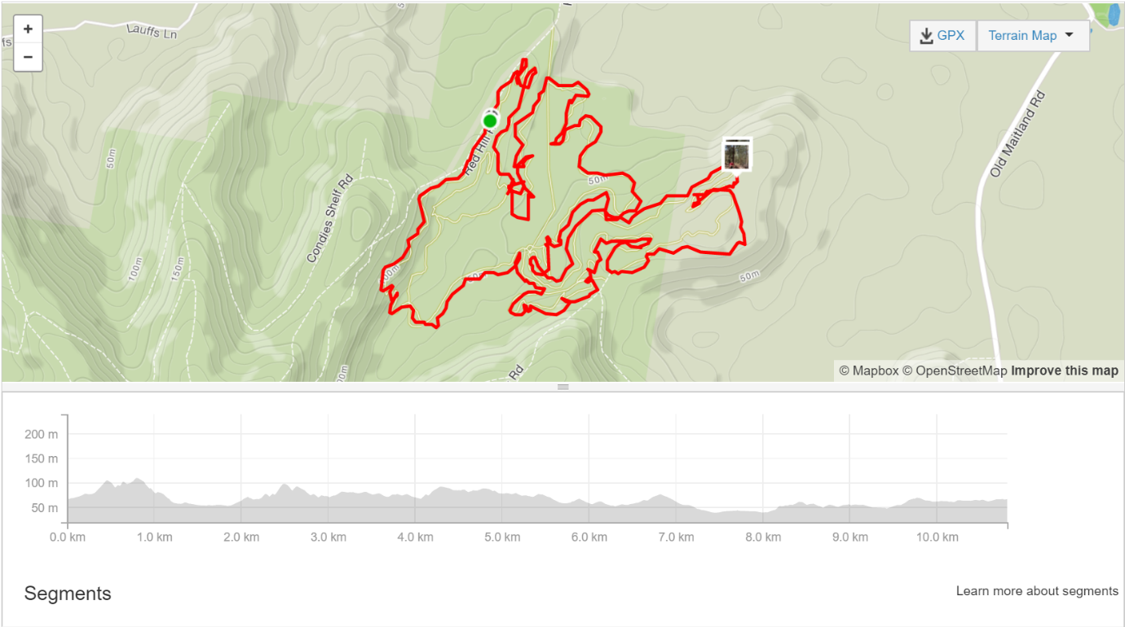
Ride Distance: | 10.8 km | Altitude Gain: | 182 m
Grade: | Medium Hard | Average Pace¹: | 10 km/h
Ride Surface: | Single Trail | Est. Duration: | 1.0 – 1.5 hrs
Ideal for: | MTB only | Child Suitable¹: | n/a
RidesAssist: | No
A short but testing MTB ride on the Ourimbah XC trail for experienced mountain bikers, mainly on single track with minor sections of fire trail. Some interesting sections of difficult short climbs and technical, rock-garden navigation moments through the forest. Fortunately, there are some terrific sections of flowing run with some great fun down the aptly named “rollercoaster” and the “graveyard”.
Meet at the trail head 15mins prior to ride start time: enter via Red Hill Rd Ourimbah State Forest, past TreeTops, park nose-to-curb near the CCOMTB notice board.
Please NOTE: There are no toilet facilities here – so go before you go…

For more information on this ride including when it is next scheduled, please refer to the CCBUG Rides Calendar at www.ccbug.org.au or check out our events on Facebook www.facebook.com/CentralCoastBicycleUserGroup
Ride Details –
Meeting Point:
Enter via Red Hill Rd, Ourimbah State Forest. On your right will be 'TreeTops' for the kids and it's large-ish carpark. Carry on past Tree-Tops, MTB parking and official trail head is now designated a further 350m or so up the road where there is a larger area easily identified by the Shipping container on Red Hill Road. There's a CCOMTB notice board here by the trail entrance (on the left as you drive up the hill). Park up nose to curb or as directed.

Be there 15 minutes prior to the ride start time!

About the ride:
A medium to hard grade ride on mainly single track with minor sections of fire trail.

Some interesting sections of difficult short climbs and technical, rock-garden navigation moments through the forest. Fortunately, there are some terrific sections of flowing run with some great fun down the aptly named “rollercoaster” and the “graveyard”.

On the super-challenging sections we will stop in advance to forewarn anyone unfamiliar with the track or uncertain of their abilities. We will also be stopping at all intersections/forks to keep us as a group. So, to those familiar with the track there will be several stops.

You will need:
- a fully functioning mountain bike, in good service and ready to go.
- Full compliment of at least the basic safety gear including;
  - Helmet
  - Gloves
  - Eyewear (really important – lots of branches at eye level on the single track)
  - Shoes
  - Elbow/Knee pads (optional)
  - Water – backpack or bottle enough for the ride 1.5 hours
  - Spare tubes/pump

Coffee and banter will be at the McDonalds at Tuggerah afterwards, getting there by car after the ride.

From the car park the ride is 98% single track. The direction and flow of the track is well sign marked with some traversing the fire trails in between the single track exits and where you re-join. This is marked as the “XC” track.

Two key locations to be aware of:
- 250 metres of single track from the entry and you will come across the first seg-way of fire trail. Turn left and 30 metres down the hill turn right to re-enter the single trail. From here, it’s follow the arrows
- At your next exit of the single trails approximately 2.5 kilometres in, you will hit the next section of fire trail. Turn right (you will pass the exit of the downhill on your right – DON’T TURN UP THERE)
- Climb up the fire trail to the first crest and to your right you will note an entry (and well worn path) to the next section of single trail. From here you will be entering the “burnt forest” section which is a series of short climbs and tight twisty sections with a small rocky climb at the end.

There are a few challenging sections that require a high level of skill and experience to navigate successfully. Beginner riders can take an alternative route, which I will stop for and direct people to the easier section, or alternatively walk the bike through the obstacles.

The first is a serious 3 metre vertical drop, which is really intimidating, even for some experienced riders. There is an easy out path to the left which can be walked for beginners or ridden down easily.

Mountain biking is quite testing on fitness levels as the pedalling differs significantly from road. The effort is intense and is often delivered in bursts to get over the obstacles.

Opt in points
Only the trail head.

Opt out points
There are several opt out points.
- 2.5 kilometres in when we hit the second section of fire trail which when turning left, will take the rider back to Redhill road and then further, on to the car park.
- Bottom of the rollercoaster
- Before the “graveyards” section

Water & Toilet Locations

None: You will need to bring enough water for yourself to cover a minimum of 90 minutes riding. Toilets are located in a short drive to Tuggerah at either Westfield or McDonalds as landmarks.

Map Reference:

https://www.google.com.au/maps/place/Central+Coast+Mountain+Bike+Club+Trailhead/@-33.2797329,151.3741059,17z/data=!4m13!1m7!3m6!1s0x6b72cd4ed043c85b:0x26a225f04967bbf5!2sRed+Hill+Rd,+Ourimbah+NSW+2258!3b1!8m2!3d-33.28845!4d151.3301822!3m4!1s0x0:0xef115ce5098666c2!8m2!3d-33.2791398!4d151.3746587?hl=en&authuser=0

Ride Leaders Notes:
Simply put there are only a small handful of serious obstacles for an average, well rehearsed mountain biker.
They are:
- The 3 metre drop – check the gradient!
- 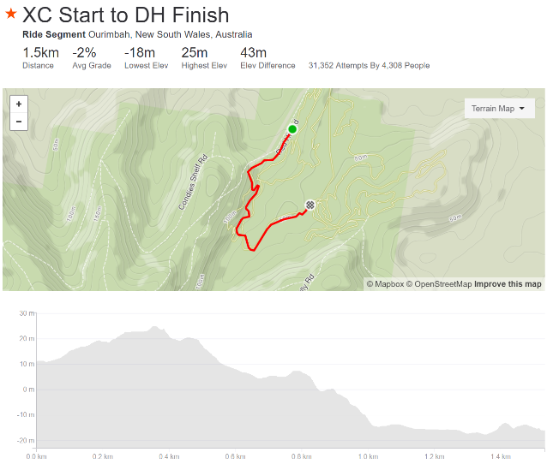
- The bottom of the rollercoaster has a drop over a rock ledge which looks daunting but isn’t too bad. It has also been made easier by the club with the addition of rocks to lessen the steepness of the drop
- If you take the right to the “Magic Carpet” section there is a difficult section of elevated timber track that turns back on itself. What makes this difficult is that it is elevated about 3-4 metres and is tight against the wall of the hill. The difficulty is not just the turn but keeping the bike on the elevated timber track as it can be quite narrow. You can bypass this section altogether if you are with riders of lesser confidence by continuing straight ahead at the bottom of the rollercoaster. You will know you are there as it is adjacent to the fire trail from earlier in the ride.

Cue Sheet –
Distance Marker | Direction | Street / Location | Hazards / notes
0.0 | Start | Enter the single trail “XC” from the Carpark – adjacent to the shipping container | Single trail, tree roots, rocks, wildlife
0.150 | Left | Turn left onto the first section of fire trail | As above
0.180 | Straight | Proceed down the hill for 30 metres
 | Turn right | Look down the fire trail to your right – you will see the next entry to the “XC” trail – Enter the XC track  Follow the trail.
2.1 | Right | Turn right onto the fire trail and continue for approximately 150 metres.  Some climbing here. | - Sand  - Some rock as you climb
 | Right | At the first natural crest you will see a right turn which leads you on to the burnt forest | Up and down with some twisty’s thrown in
 | 5 ways. | At the end of the “burnt forest” section you will come to the 5 ways. | Stop and re-group
This is a decision time – if the crew are feeling it you can drop a section by going straight on to the jelly legs section
If not, you can turn left and follow the single trail
 | Turn left at the 5 ways | Follow the single trail, cross the fire trail and follow the single track | Just a couple of quick steep climbs and some easy rocks to navigate over
 | Continue on | Continue on through the section to Jelly legs climb, then on to the rollercoaster | Jelly legs climb has a rock garden climb which will require some effort – easy stop point at the top
About halfway  5km mark | Continue on Rollercoaster | Enjoy the rollercoaster  Be safe – the final section has some drop-ins as part of the descent | Once you cross a man made wooden bridge be aware that a rock descent is 50M ahead. Some riders may get off and walk
Stop | Bottom of the rollercoaster | At the bottom of the rollercoaster there is a fork.  - Turning right leads to the Magic Carpet – not for beginners  - Going straight cuts approximately 500 metres of technical section which is a mix of steep and wooden path against the hill. | The elevated wooden path against the side of the hill
 | Continue on | This is a great section if the trail known as EWOK Forest. Great section which leads to the Graveyards – note the drop… | Be aware of the steep, rocky descent as noted by the three down arrows.  I have personally found a rider unconscious at the bottom of this short descent.  The easy way out is to turn right at the top of that section. Don’t forget to give way to riders doing the steep section
 | Continue on | Opt out moment:  Get out of jail free card here. Prior to commencing “the Graveyards” section you can turn left, head to the fire trail, turn right and that will lead you back to RedHill road and the on to the car park | The graveyards is fun, flowing and easy down the bottom of the trail
 | End of Graveyards | Muster and re-group point  About 3 or so K’s to go | Cross the fire trail
 | Continue on | Continue on to Forest is lost – it’s a left turn and is sign posted | You’re on the home straight…almost
 |  | 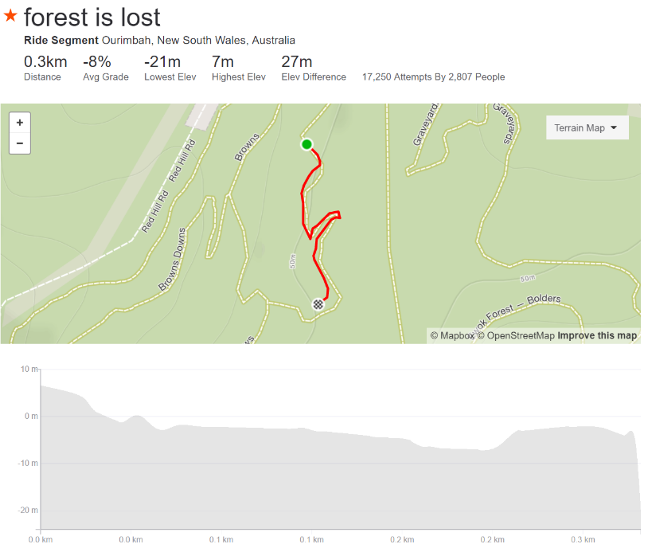 | Continue to Short meadows if the group is tiring
 | Continue on | At the end of the “Forest is lost” you will come to a fork – another natural re-group point.  - Turn right and you will go up towards short meadows and browns then on to the switchbacks and the climb to the car park | There is an “A” line through browns which includes a double jump – avoid this unless you are an “A” grade rider  - Take the “B” line
 | Continue on | Continue to the switchbacks and the climb out to the car park | Narrow track between the trees
 |  | 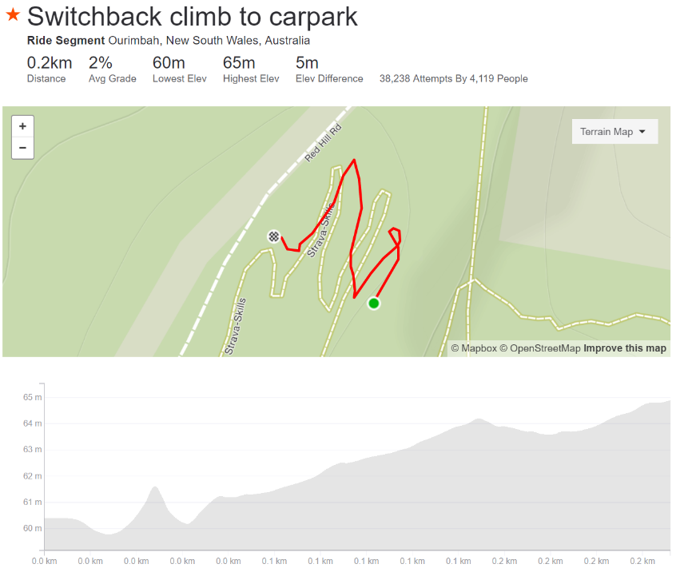

Refer to the www.ccbug.org.au for more information.

